High School SEBS at Home Support amid COVID-19 Closure
From School Based Learning

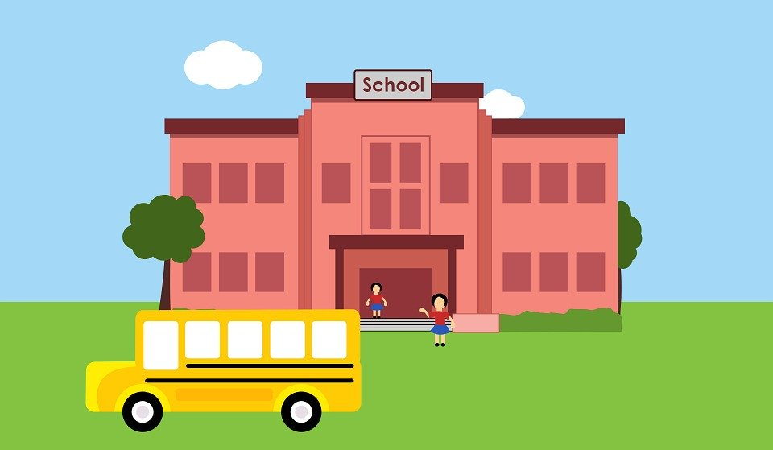

To Home Based Learning

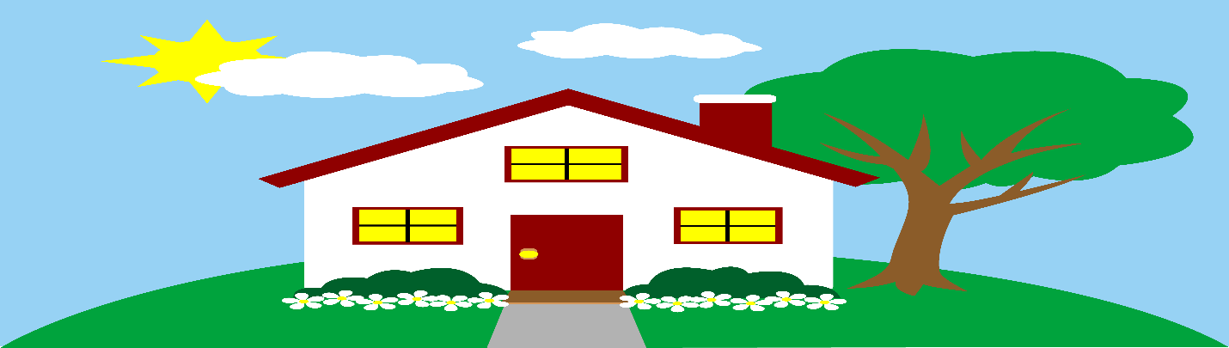
This Photo by Unknown Author is licensed under CC BY-NC

The transition from leaving home and attending school or going to work each day to remaining at home has not been easy for some students and families.

Suggestions to Support your Student’s Social, Emotional and Behavioral Health at Home

Establish family routines/schedules:
- Set bed-time, wake up time for M-F
- Schedule school-work time – at least 2 hours in morning; up to an additional 2 hours in the afternoon
- Set meal-times for the family – breakfast, lunch and dinner
- Schedule outdoor physical activity 2 x day for 30 minutes – morning, afternoon
- Identify a family activity daily – a family walk, a puzzle, a movie, house project
For example:
8:30 am: wake up
9:00 breakfast
9:30 -11:30: school work – Unified classroom or Google Classroom
11:30-12:00: (outdoor) physical activity
12:00: lunch
12:30-1:30/2:30: school work
2:30-3:30: (outdoor) physical activity
4:00-5:00 kids choice activity (video games, social media)
5:00: chores, help prepare dinner
6:00 dinner
7:00-8/9:00: family activity (walk, games, puzzles, a movies, home project or craft, kids teach parents something they like)
9:00: kids choice activity
10:30 bedtime

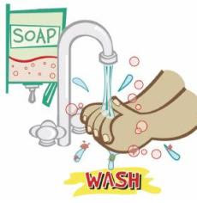
Wash hands before snacks, breakfast, lunch and dinner

Give your student a quiet space with their laptop to complete their work

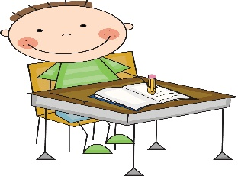
This Photo by Unknown Author is licensed under CC BY-SA-NC

Encourage your student (and yourself) to keep a daily journal to help your student and family with coping, mindfulness, anxiety - you can also write stories poetry, songs, etc.

Contact your mental health therapists/counselors via phone or Zoom.

If you need crisis services call: 413-733-6661, 417 Liberty Street, Entrance B, Springfield

Here are great websites where you and your family can go to do yoga or meditation:
- Yoga For Teens /Yoga With Adriene
- Yoga to Calm Your Nerves/10 Minute Teens Yoga Class with Yoga Ed./Ages 13-18
- Yoga para los jóvenes (español)

Please contact your student’s SEBS Teacher, Clinician or Behavior Specialist when you need assistance and respond to them when they reach out to you

