HOW TO ACCESS EARLY START Program
If you are having trouble with your internet, your computer may need to be restarted at a SPS school( ANY SCHOOL) so you can connect to the SPS wi-fi. Hold the power down for 10 seconds, wait until computer shuts down. Wait 10 seconds, than push power button again and log in. Your computer should restart & upload
Log into your computer using your Lunch ID as your log in and then your password will be Sp than your birthday, example Sp010204
You can use the internet on your computer……type in www.springfieldpublicschools.com

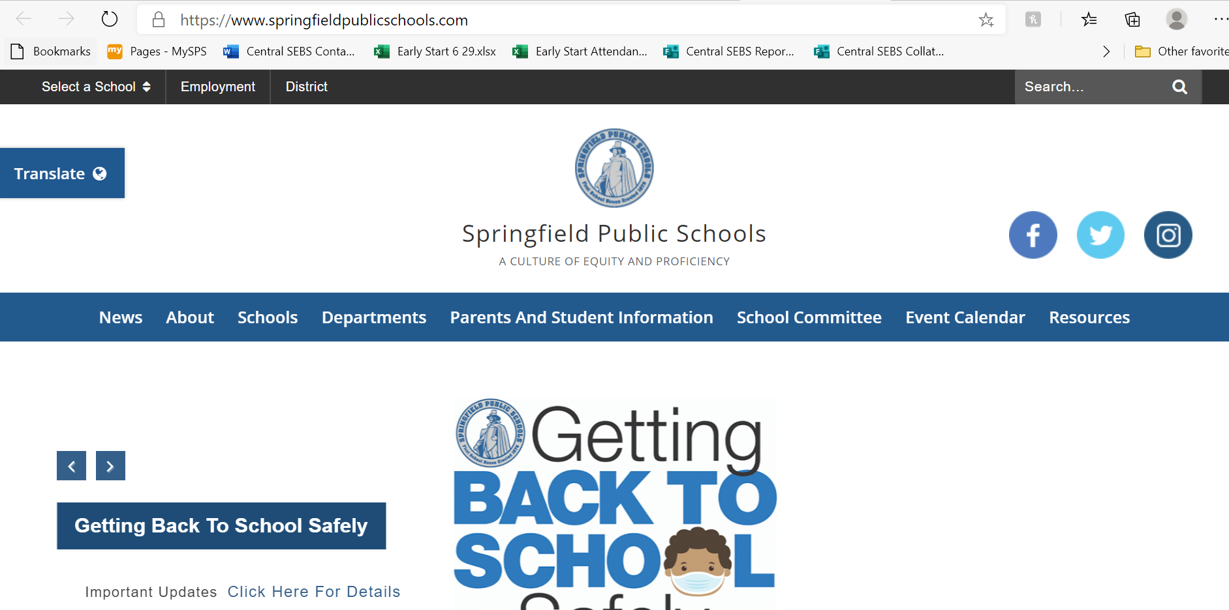

fd,.kfdklfdklfkk Scroll Down and click Students
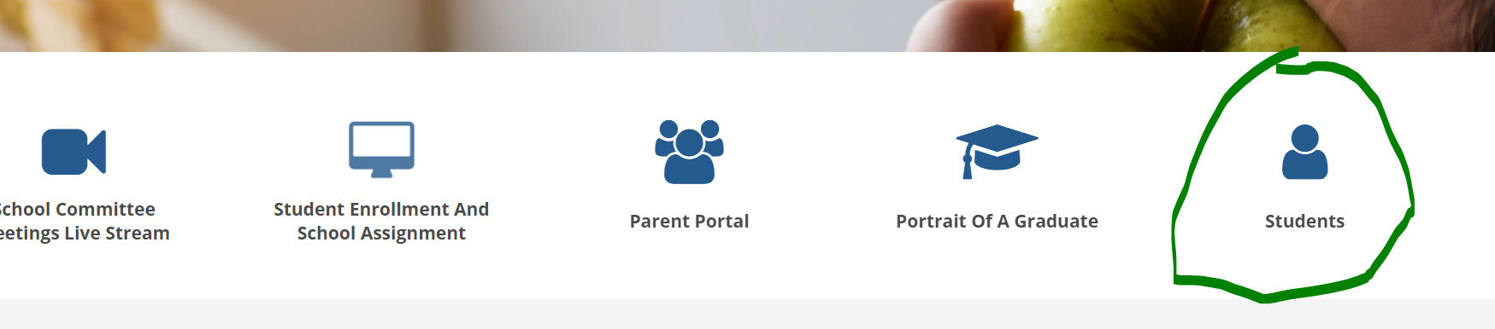
Click this link to student apps
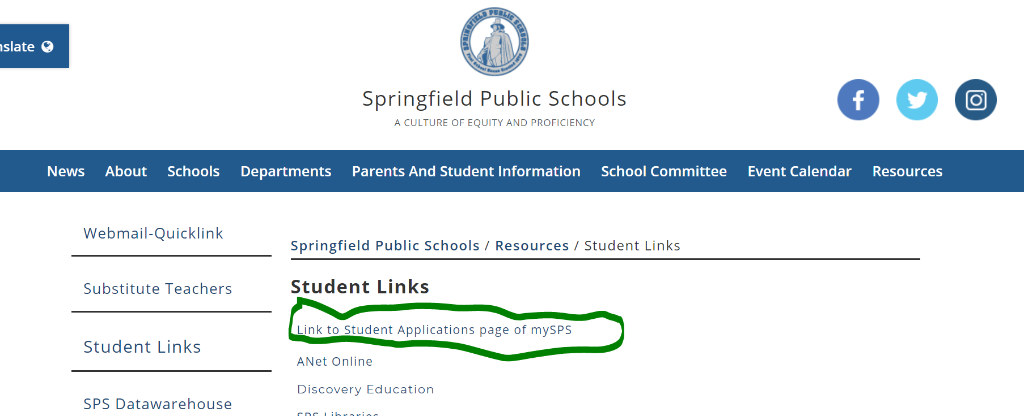
This is the Application screen, where you can access everything you need.
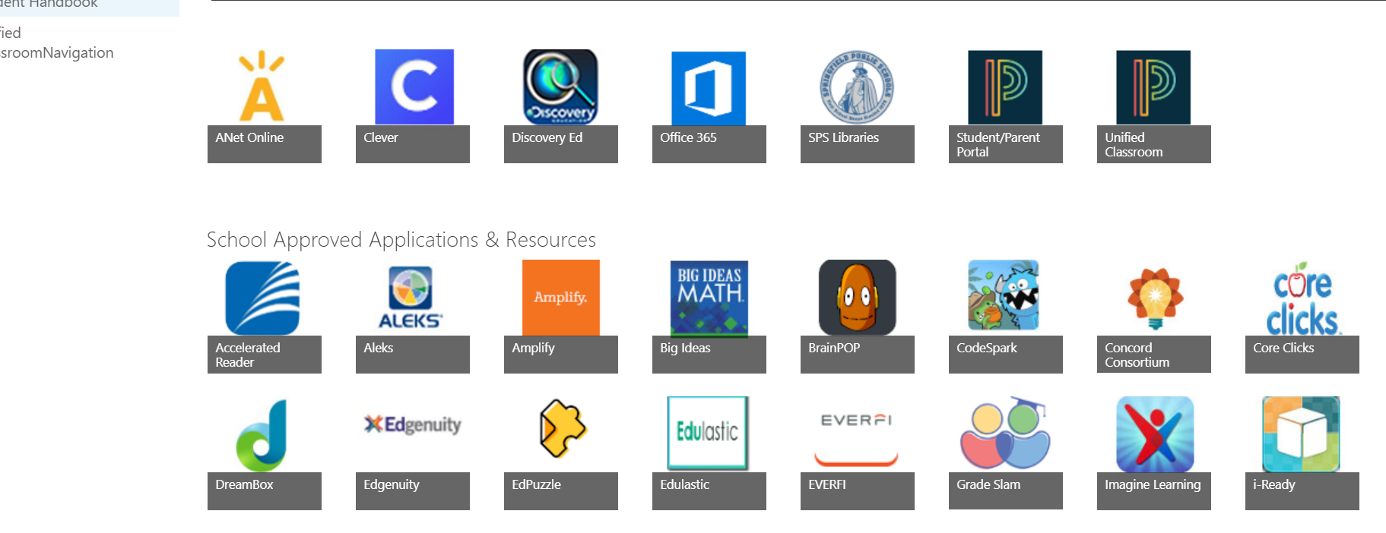
By clicking office 365, this is where you can access your EMAIL, TEAMS( where your classes are) Microsoft Word and Excel
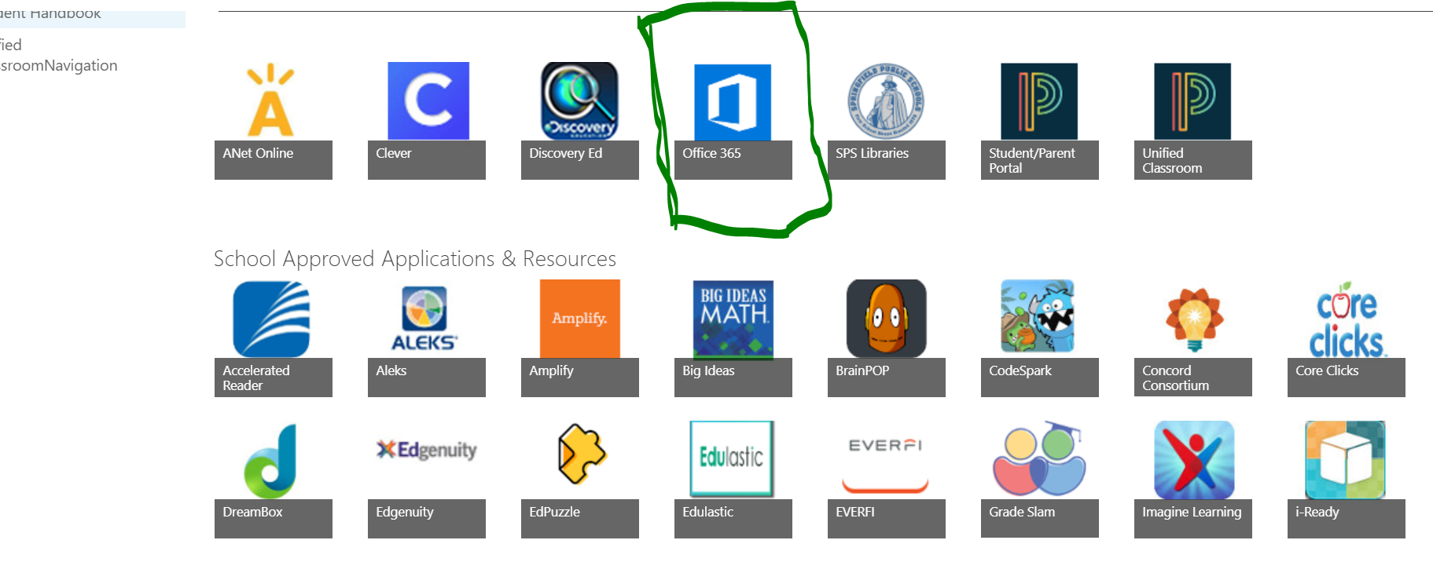
Use the same log in information that you used before, if you need to …. Here is where you will go
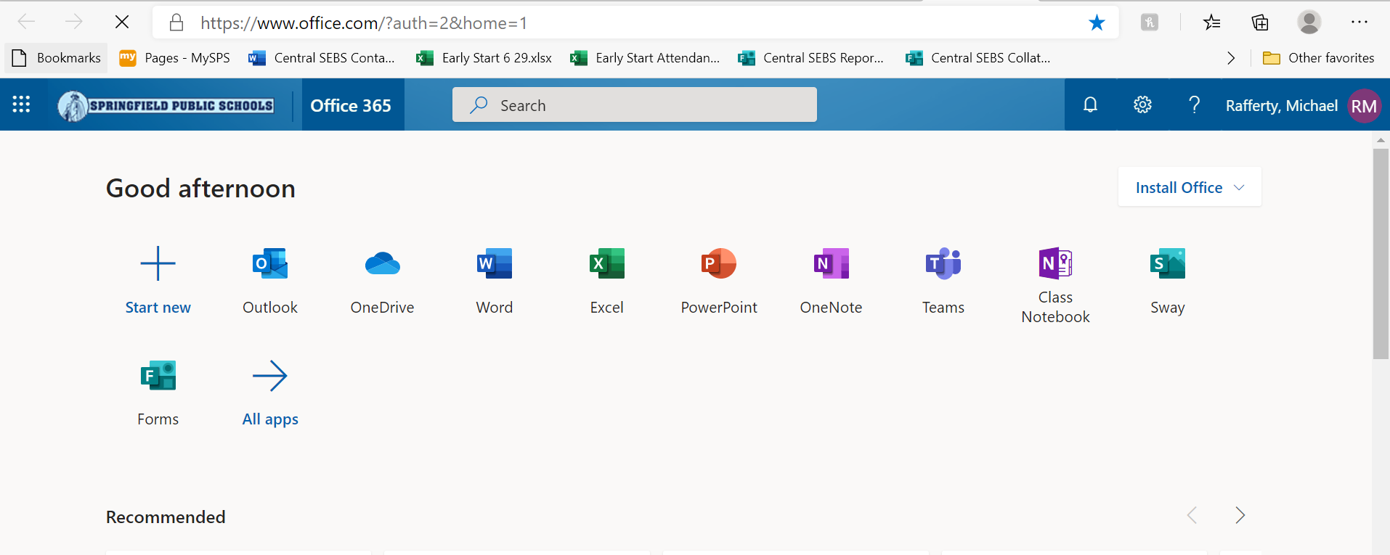
Click outlook to access your email 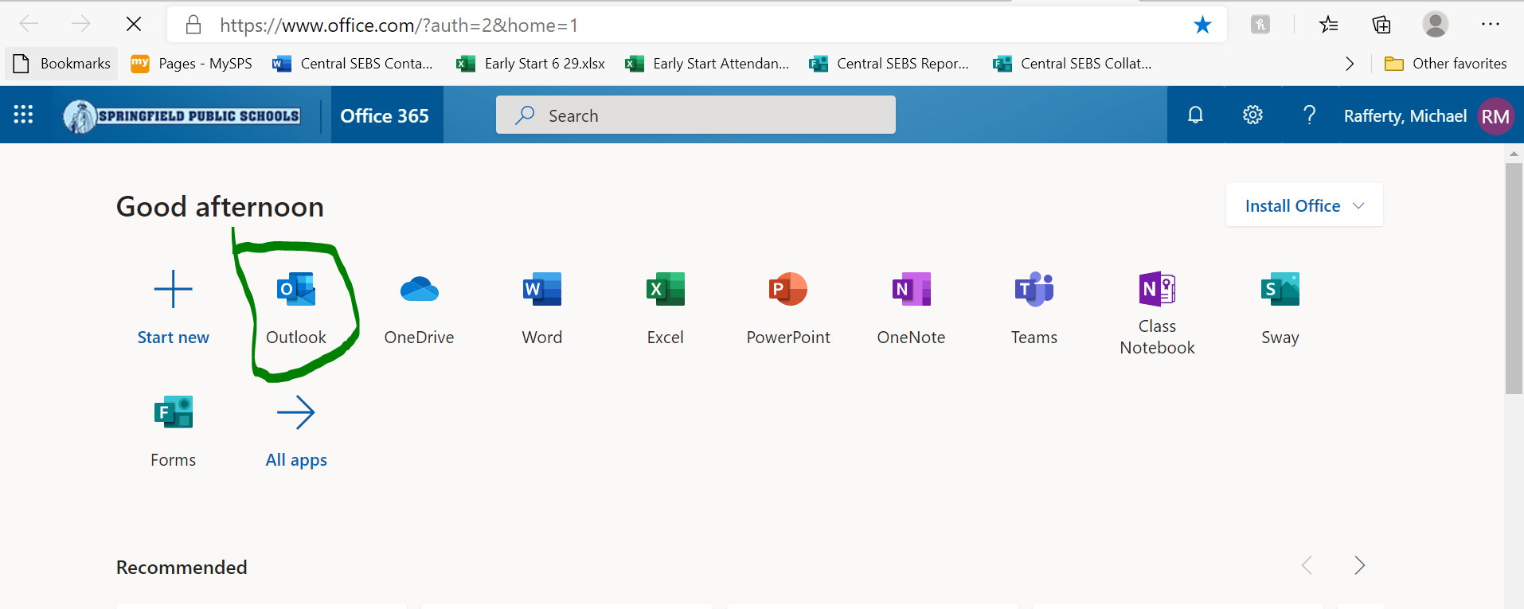
Here is how you access your email and you can write your teacher an email to ask questions or send them work. Click NEW MESSAGE
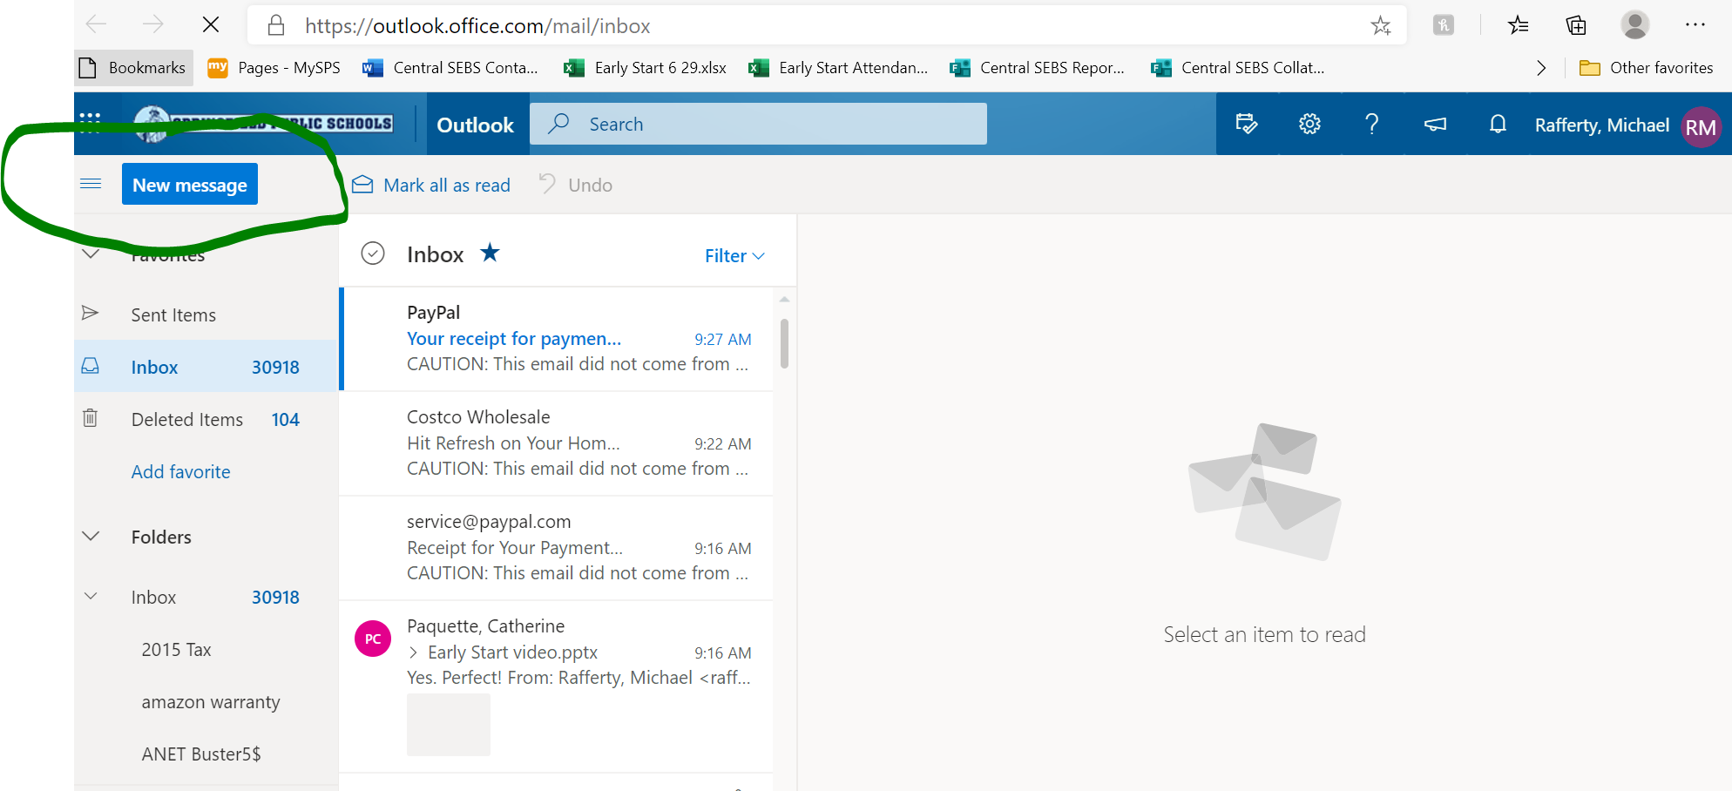
Type In the teacher you would like to contact in the “TO” section
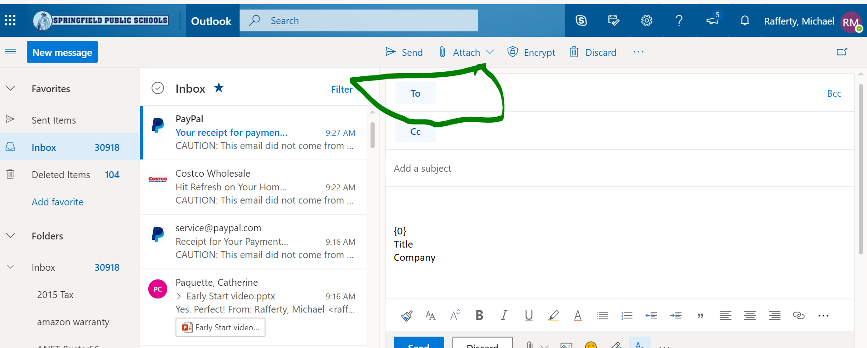
WHEN FINISHED MAKE SURE TO HIT SEND
How do I join TEAMS for my classes. Go back into your office 365 and click TEAMS
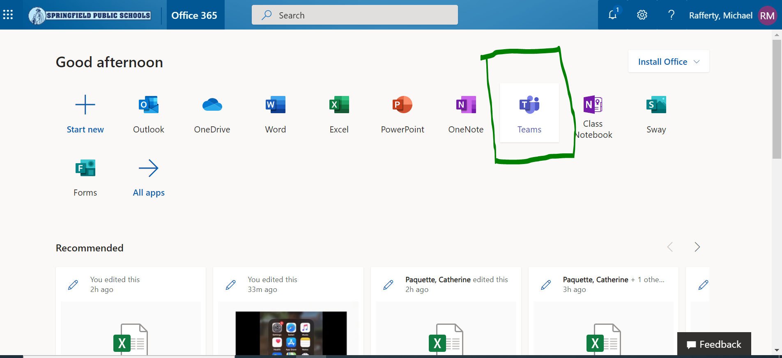
Find the icon for your classes below, including Math, English and Bio… HIT THE NOTIFICATION BUTTON TURN ON!!
